**Instructions for using the Digital Manuscript platform**

**User interface**

**Top left nav bar:**

**General description button** – click it to display the SHORT version of the description of the scroll. (The data for this is grabbed in the “abstract” tag in the XML file in the “General Description” folder)

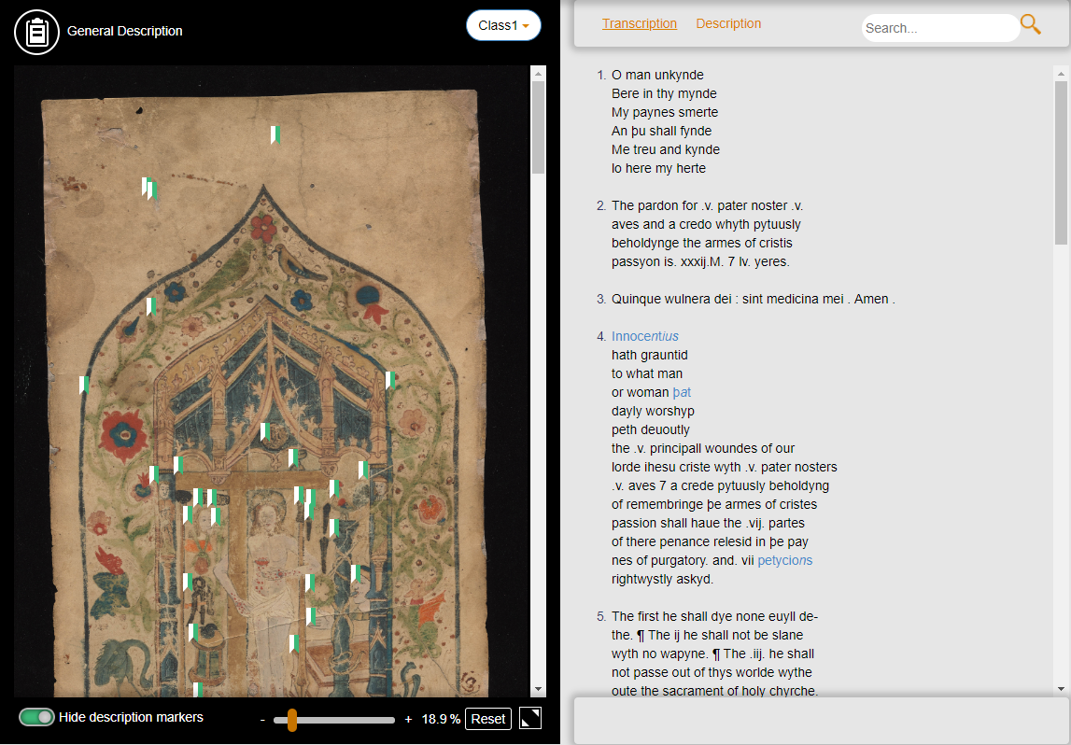

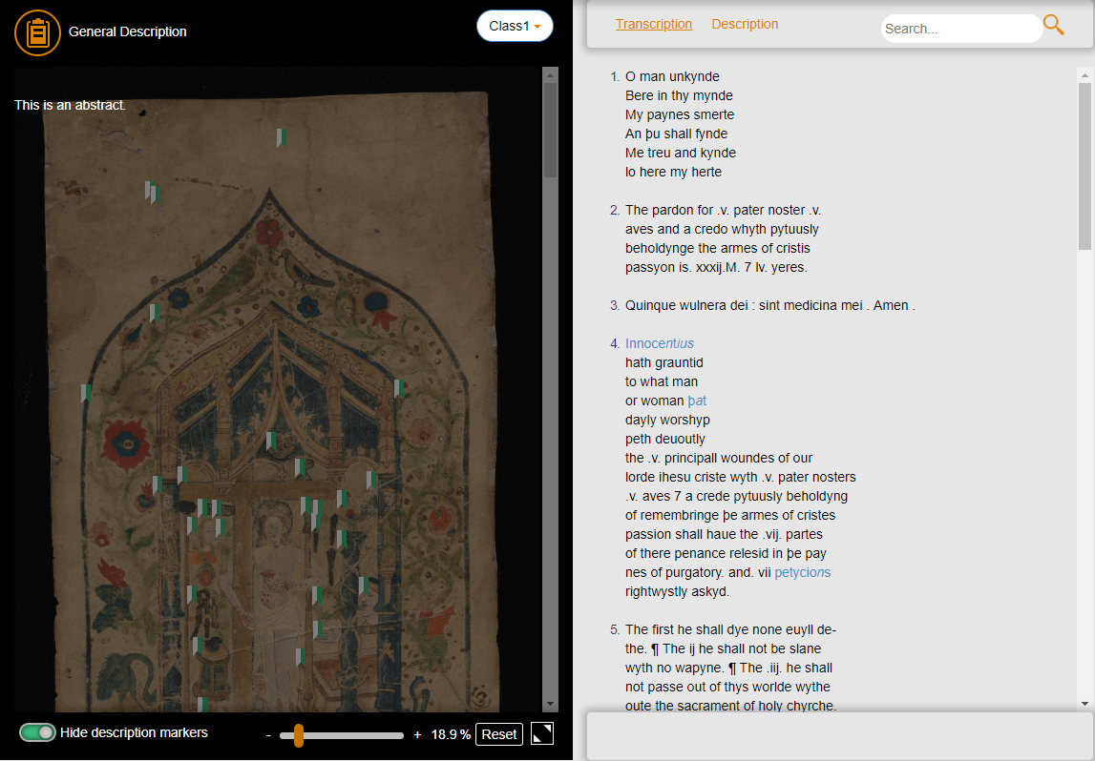

**Class dropdown menu** – this dropdown menu will show the different scrolls and classes when you click it.

The dropdown list is populated by the folders that the faculty puts in the specified location. The list shown will be the names of the folders. The faculty can name the folders anything they want and it will be displayed as such on the dropdown list. (For e.g. Class 1, Scroll 1, Scroll 1 – Class 1, etc)



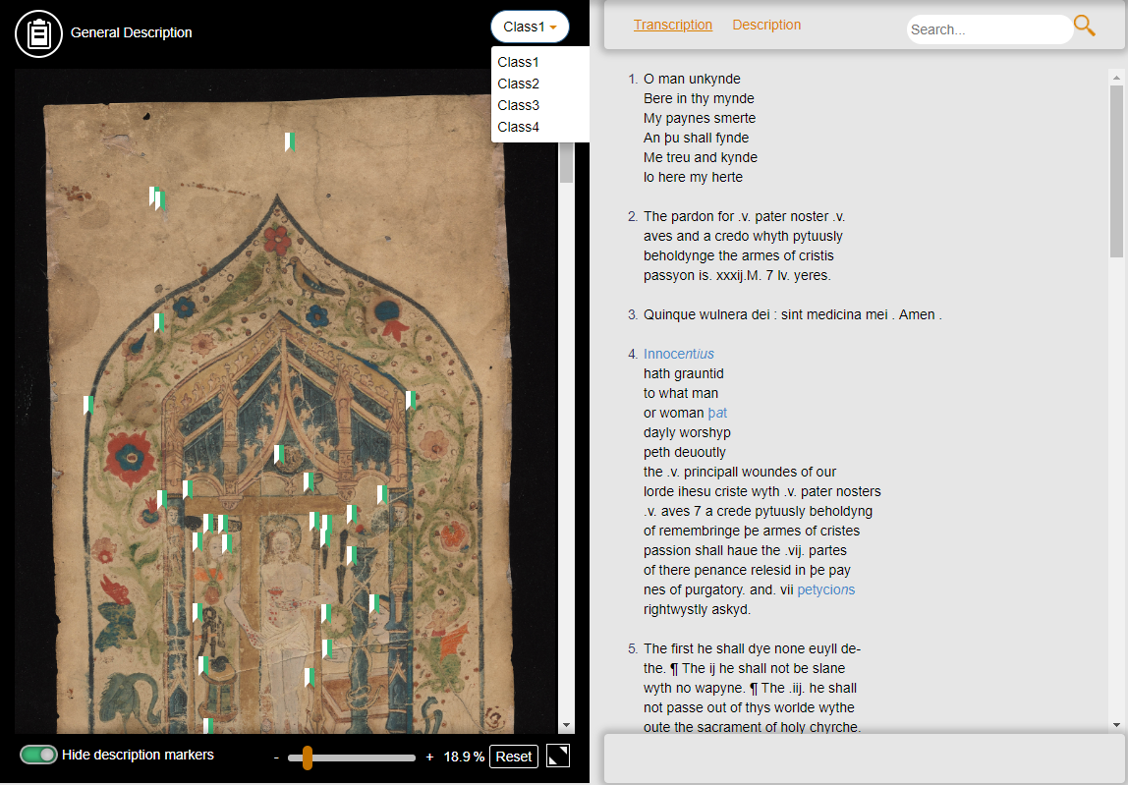

**Left side content:**

**Scroll image** – The scroll image will be shown here. If the image is bigger than the window, a scroll bar will appear on the right for you to scroll the image. You can also pan (click the mouse and drag on the scroll image) to move the image in any direction.

Hovering over certain parts of the scroll image that has text, will highlight that part of the text, along with the corresponding text in the “transcription” page on the right side. If the corresponding text in the transcription page is not in view, clicking the area in the scroll image will cause the corresponding text in the transcription page to automatically scroll into view.

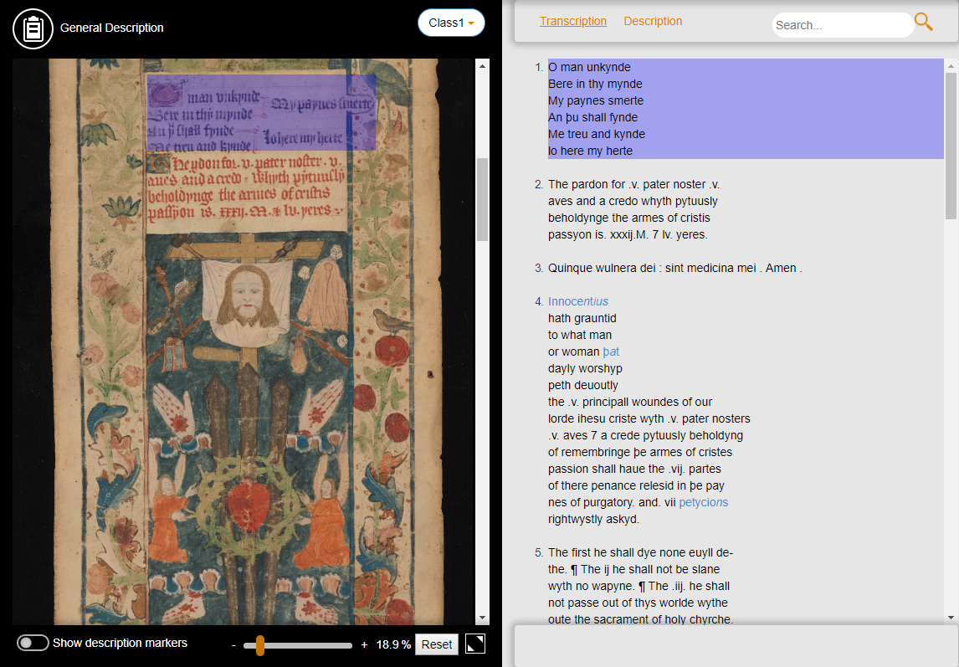

The description markers will also be shown on the scroll image. Clicking on these markers will bring up the highlighted area (in translucent blue) and the corresponding description about that area in the scroll will appear above it.

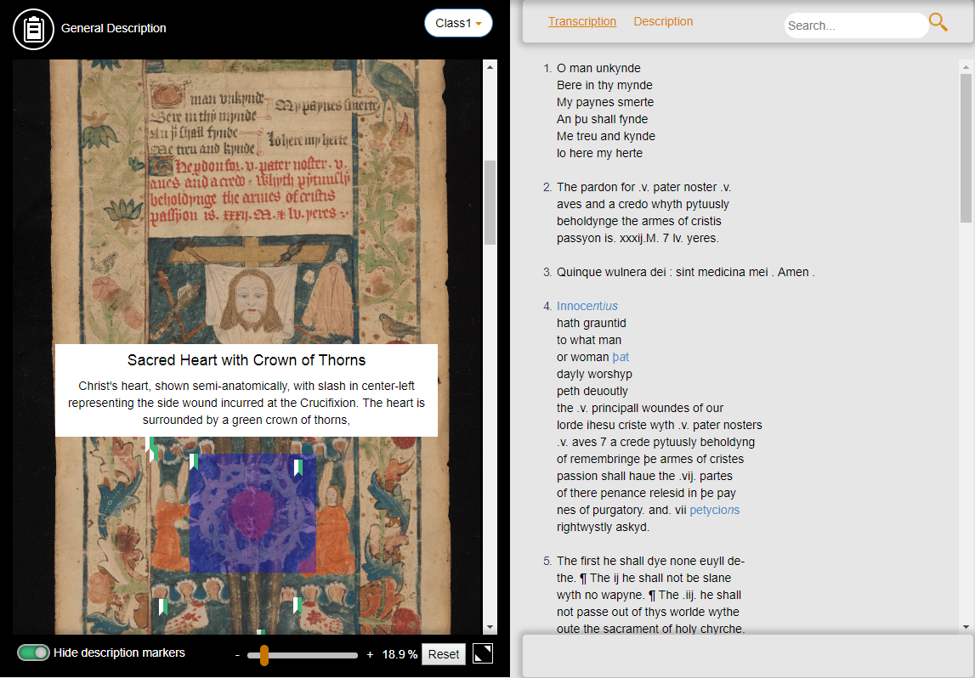

Clicking an **open** marker will close it. Clicking **another** marker will automatically close the previously opened marker, so at any one time, only one marker description will be displayed.

**Bottom left nav bar:**

**Show/Hide description markers button** – This button will show or hide the aforementioned markers shown on the scroll image.

**Zoom slider** – The user can drag the slider to zoom in or out of the scroll image. The user can also press on the “+” or “-“ button to zoom in and out.

**Reset button** – This is to reset the image zoom to the original zoom level.

**Fullscreen button** – This button will open the scroll image into a fullscreen view.

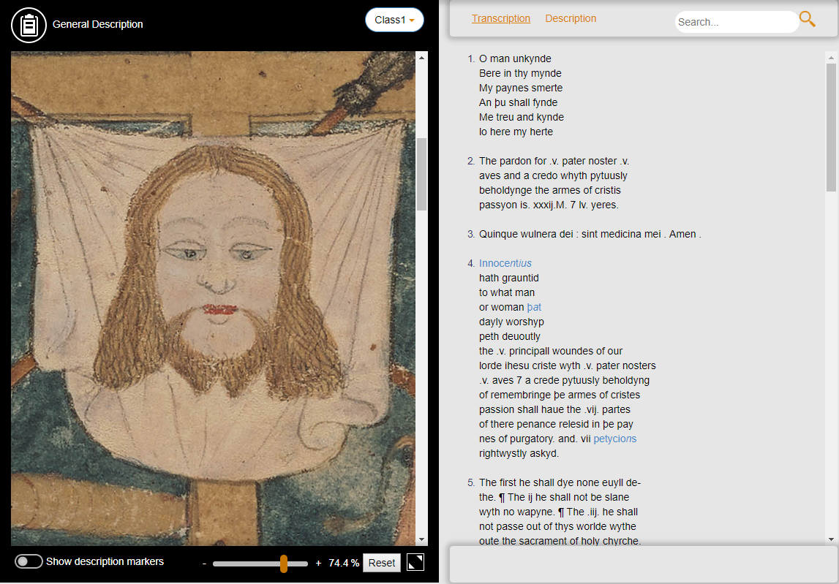

**Top right nav bar:**

**Transcription button** – This is the button that will be pressed by default. It will show the transcriptions of the scroll in the page content.



**Description button** – Pressing this button will show the description of the scroll.

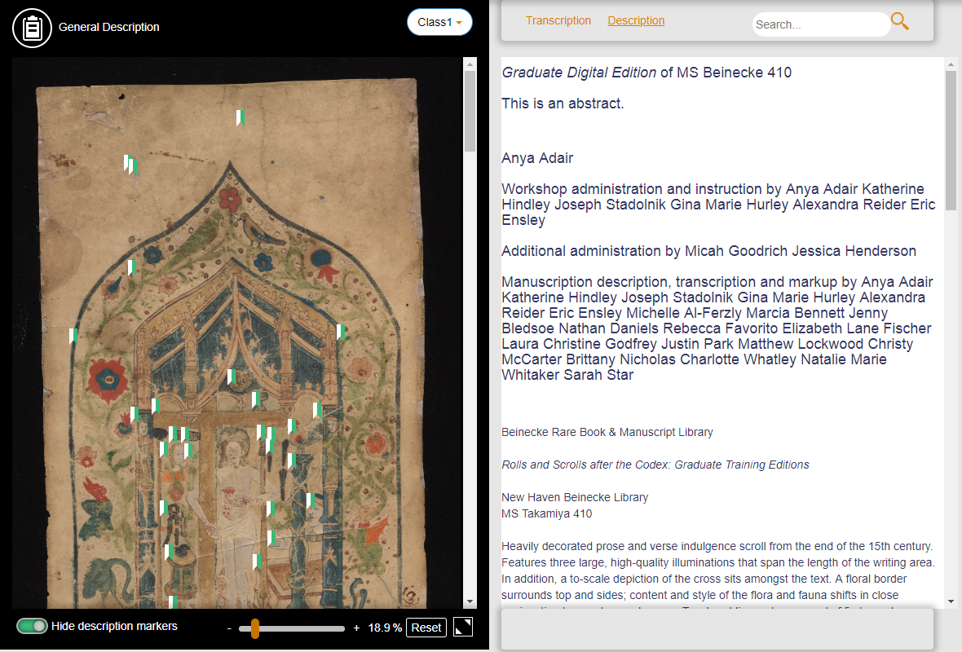

**Search bar** – Type anything into this search bar, then if you press the magnifying glass icon beside it, the text you typed into the search bar will be highlighted in the page.

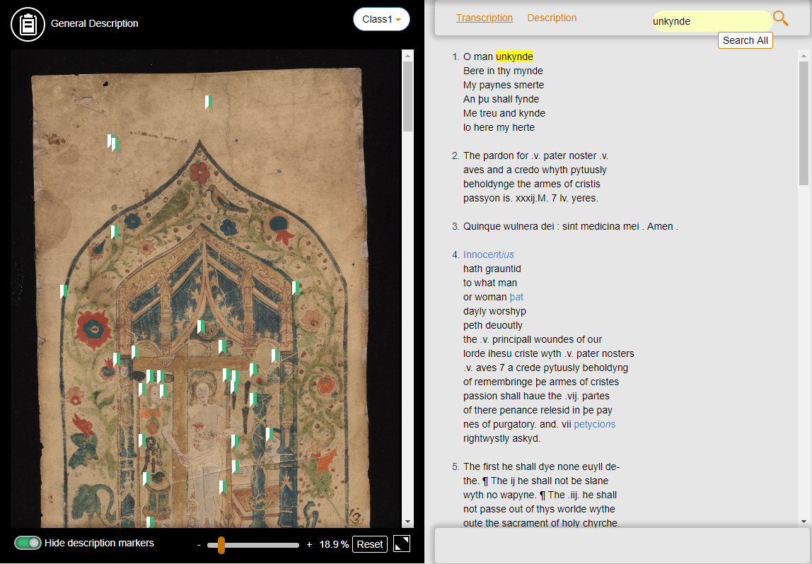

Also, a “search all” button will show up below the search bar. Clicking this will search throughout ALL the folders and manuscripts for the text you typed into the search bar. It will search through both description marker texts, and also transcription texts.

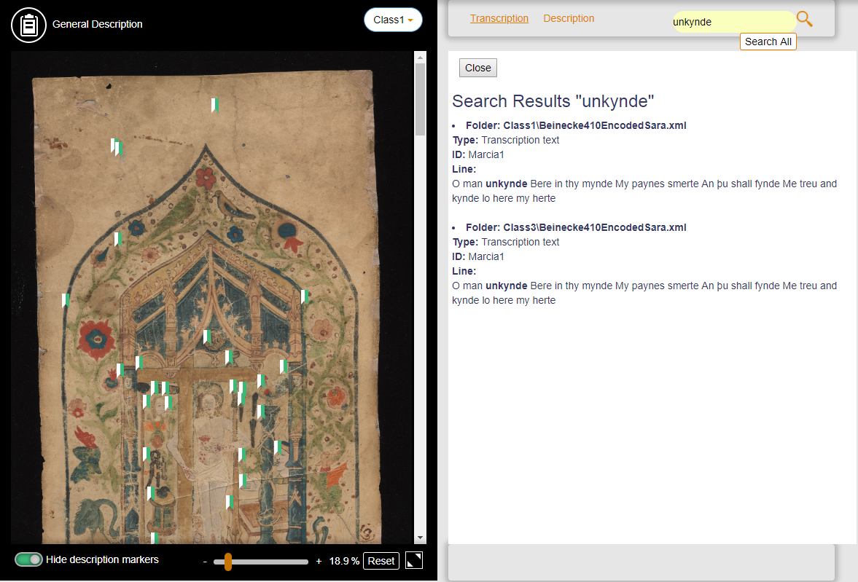

**Right side content:**

**Search results page** – This page will appear if you had done the “search all” function mentioned previously. All the search results will be listed down. The filename of the search result will be shown and also the folder that the file is in. The type of the result will also be shown, whether it is a “description marker text” or if it is a “transcription line”. The ID of the person who wrote that line will also be displayed, then followed by the line itself, with the searched word/phrase being bolded.



**Transcription page** – This page will show all the transcription lines. Hovering over the line, will highlight the line as well as the corresponding area in the scroll image that shows that line. Clicking on the line, will auto scroll the image until that corresponding area in the scroll image is in view.

Words with expansions will be coloured in blue. The full expanded word will be displayed by default, with the expanded letters in italics. However when you hover over the word, the shortened version of the word will pop up above it.



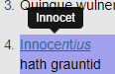

**Description page** – This page shows the full description of the scroll image.



**How to Load the files**

In the **main** “Files” folder, there will be the folders where you load all the data in, according to classes, manuscripts or folders. For example, you can create a folder named “Class 1” for class 1 for the semester. The dropdown menu on the website will simply show the names of the folders that you put here.

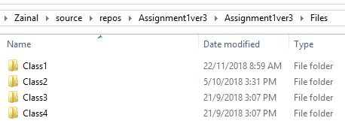

In the “Class 1” folder (or any other folder in this “Files” directory), there needs to be three folders. One named “General Description”, one named “Scroll Images” and one named “XML Files”.

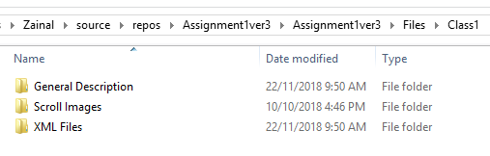

General Description

There should only be one XML file here, this is the file that the “description” page will grab its data from. Only the text under the tags “teiHeader” will be grabbed. The transcription and marker texts will be ignored, as this file is only to populate the “description” page. If there are multiple files, the program will only read the first file here.

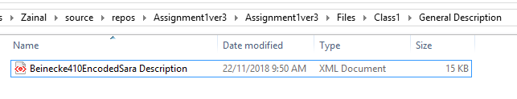

Scroll Images

There should only be one image here, which is the scroll image that will be displayed for this class. If there are multiple files, the program will only read the first file here.

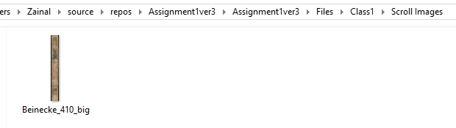

XML Files

Here will be all the XML files that contain all the information. Such as the image coordinates (to show which area of the image belongs to which line, and also to show which area of the image has descriptions), and also all the transcription lines and also the description marker texts. There can be multiple XML files, as the program can read multiple XML files. However all of them must follow a certain format, which will be discussed in the next section.

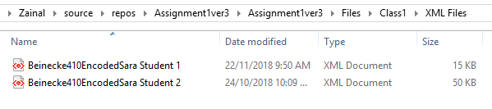

**How to format the XML files**

The info in the “description” tag is only grabbed from **one** XML file in the “General Description” folder. If there are multiple files, the program will only read the first file here. (alphabetically).

**<abstract> tag** – This is where the SHORT general description will grab its data from. So you may write down a short description of the scroll here.

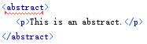

**<teiHeader> tag** – This is where the long general description will grab its data from. Everything within this tag will be displayed in the page under the “description page”.

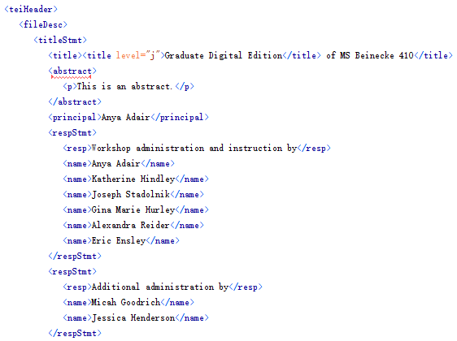

**<title> tag –** The title tag on its own does not do anything.

**<title level=”m”>, <title level=”j”> tags -** if the title is labelled with level “m” or “j”, it will be italicized.





**<title level=”a”>, <title level=”s”>, <title level=”u”> tags -** if the title is labelled with level “a”, “s” or “u”, it will be displayed normally.

**<titleStmt> tag –** This tag makes all the text that are within it to look bigger in the description tab.



**<list> tag –** everything within this tag will become part of a bullet-point list.

**<item> tag –** The item tag needs to be within a <list> tag. These will be the items in the list.

**<locus> tag –** The text within this tag will be bolded.

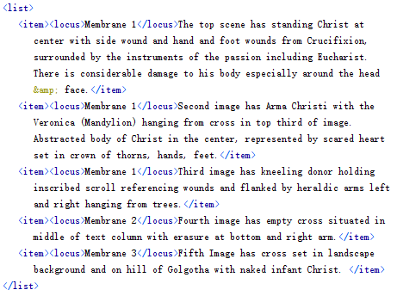

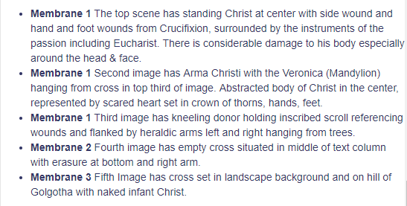

**<principal>, <respStmt>, <publicationStmt>, <seriesStmt>, <sourceDesc>, <idno>, <head> -** A line break will be added before these tags so that they’ll be on a new line.

**<zone> tag** – The codes/text around the zones tags should look something like this below.

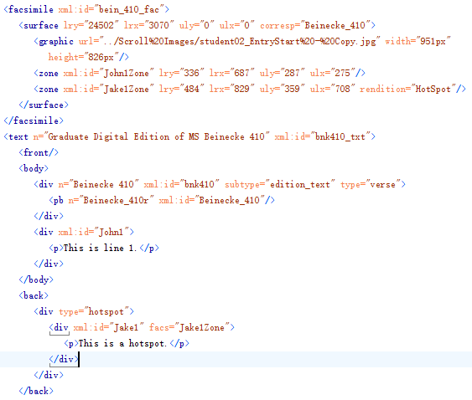

Then when you go into “Author mode” in the “Oxygen XML Editor” program, this part should look like this below.

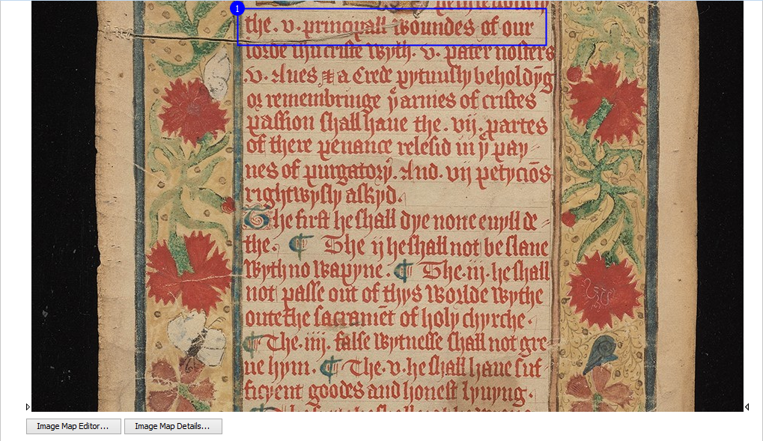

If for whatever reason, the image does not appear or is scaled wrongly, you may right click the image and select “edit attributes”.

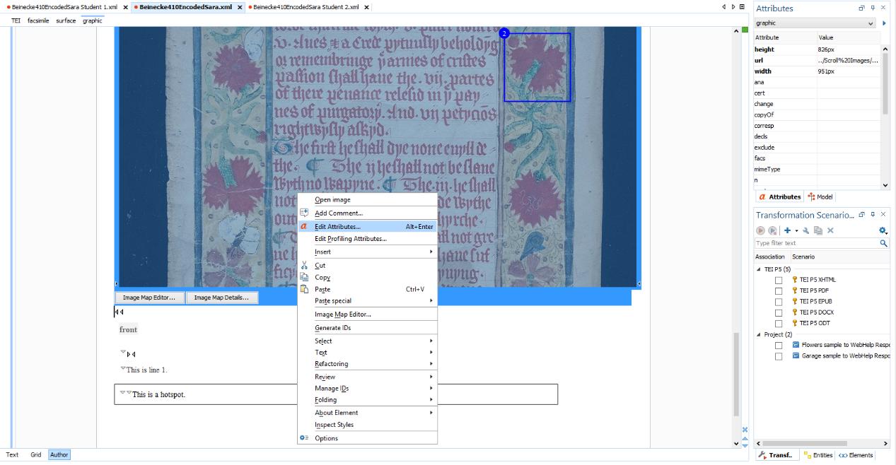

A box will appear where you can edit any of the picture’s attributes. The attributes that you can change will appear when you click the dropdown.

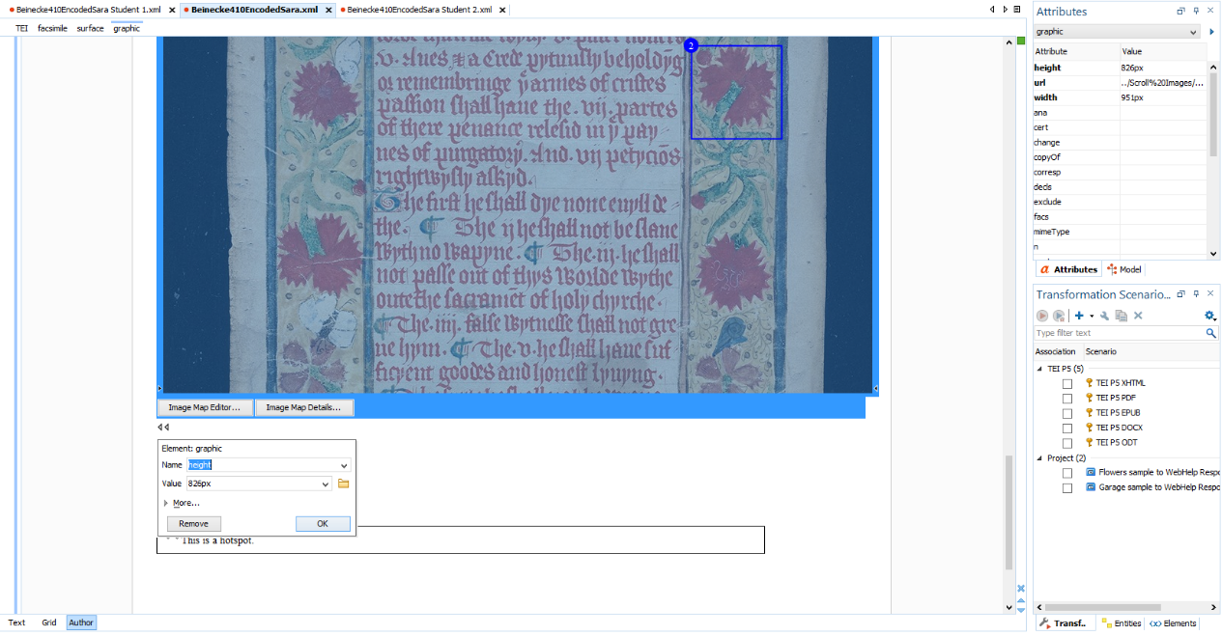

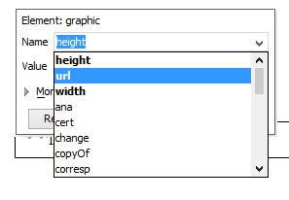

If the image is scaled wrongly, you may check the dimensions of the original image then edit the height and width accordingly.

If the image is not appearing or is not the correct image, you have to edit the “url”. You may press the folder icon to browse your directory to the image of your choice.

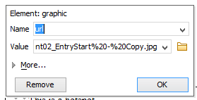

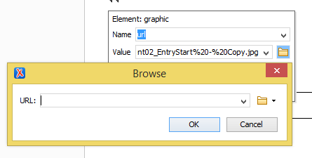

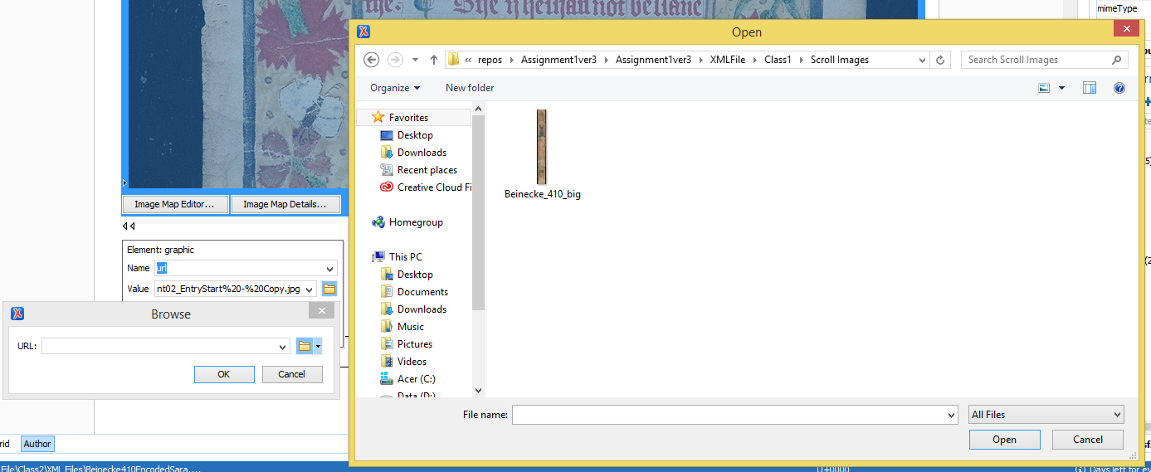

Once the image is displaying correctly, this part explains where the program will grab the codes for the hotspots in the scroll displaying the locations of the description markers and the transcription lines. The zones can be populated in “Author mode” in the “Oxygen XML editor” by using the “Image Map Editor” feature.



Press the rectangle icon and drag it until the locations are where you want. Under the “xml:id”, you should put your name, followed by a number, followed by “Zone”. (e.g. “Jake1Zone”). Each xml:id should be unique.

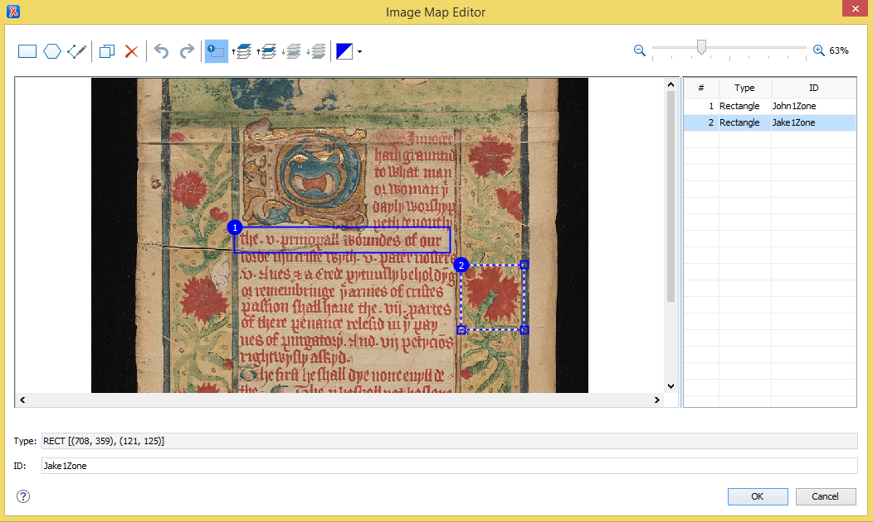

If the zone is a description marker text, the rendition of the zone should be changed to “HotSpot” (case sensitive). You can do this by pressing the “Image Map Details”, to bring up each zone, then left click the zone you want to select, then in its “attributes” section, find “rendition” and change the attribute to “HotSpot” (case sensitive).



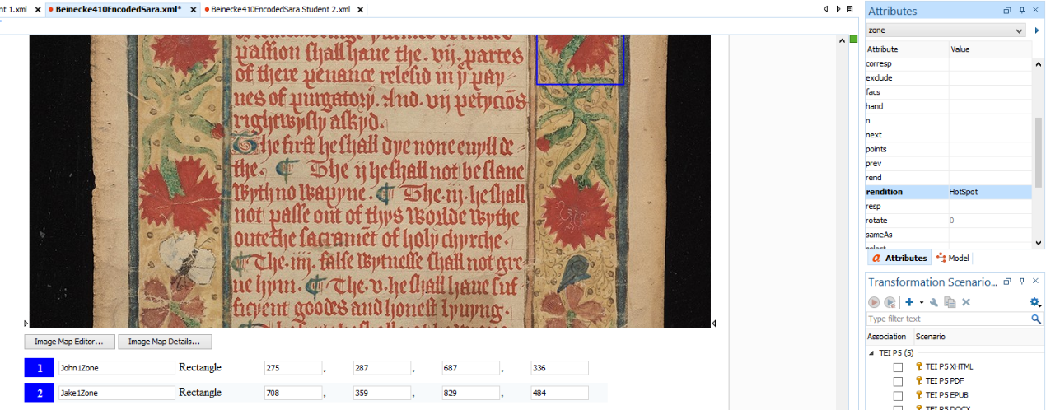

**Ordering of the Transcription lines**

For the transcription lines, the page will automatically grab all the zones coordinates from ALL the XML Files in the “XML Files” folder, it will then order them based on it’s **vertical coordinates** on the scroll image, from top to bottom. So the transcription text will also be displayed accordingly from top to bottom.

**<div> tag** – This is where the program will grab the data for the lines for the transcription text and also the description marker text.

If the line is a transcription text, the div will contain an “xml:id” which has a name, followed by a number. This xml:id must match the xml:id in the corresponding zone mentioned above, but without “Zone”. (For example, if the zone xml:id is “Zack1Zone”, the corresponding transcription text xml:id should be “Zack1”)

This works the same way for description marker texts as well (the div should also contain an xml:id which has a name followed by a number. Which also matches the xml:id in the corresponding zone but including a “Zone” behind it as well). However one difference for divs for description marker texts is that it should also include a “facs”, which points to the corresponding zone. A complete example would be <div xml:id=”Zack1” facs=”**Zack1Zone**” >. The xml:id for the corresponding zone should also be “**Zack1Zone**”.

These attributes can be added in either “text mode” or “author mode”.

**Text mode:**



**Author mode:**

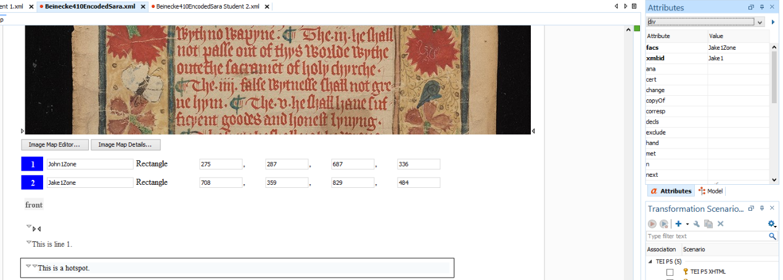

After selecting the line in the editor, if the dropdown menu just below “Attributes” (shown in the image above) is not showing “div”, remember to click it and select “div”, as the “xml:id” and “facs” attributes need to be added to “div”, and not anything else.

**<expan> tag** – contains the expansion of an abbreviation

**<ex> tag** – contains the expanded letters of the abbreviation.

An example of <expan> and <ex> being used is:

<expan>Innoce<ex>n</ex>t<ex>ius</ex></expan>

The expanded version of this word would be “Innocentius” (include all the ex tags). The shortened version of this word would be “Innocet” (do not include all the ex tags).

By default the page will display the full word, with the expanded letters in italics. However when you hover over the word, the shortened version of the word will pop up above it.

